State of Alaska
Alaska Department of Natural Resources
Division of Forestry

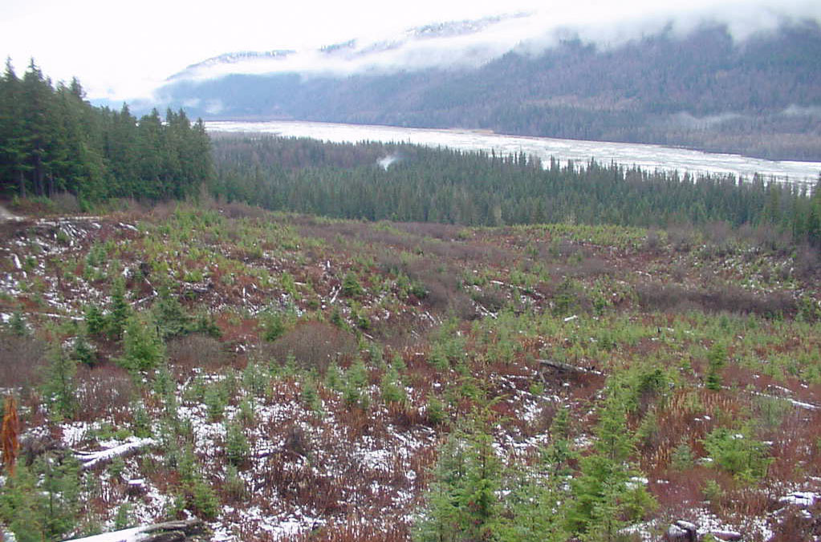

Reforestation Handbook
June 2008

Table of Contents

Section Page
I. Purpose 2
II. Legislation 2
III. Definitions 2
IV. Reforestation fund 3
V. Reforestation stocking surveys 4
VI. Survey exemption on private land 5
VII. Reforestation timing 6
VIII. Designing stocking surveys 6
IX. Detailed description of field data collection methods and computing the results 8
X. Mapping seedling distribution 19
XI. Final report 20
XII. Regeneration survival checks 22
Appendix I Theory: Nearest seedling method 23
Appendix II Waiver of sampling procedures 28
Appendix III Delineation of non-stocked (NSR) areas 29

Tables
Table 1 Stocking standards for Regions II and III 4
Table 2 Example of stocking by diameter class 5
Table 3 Plot size by forest region 6
Table 4 Number of sampling plots required 7
Table 5 Example of circular plot tally 13
Table 6 Example calculation of median number of seedlings 16
Table 7 Conversion of median to effective trees per acre 16
Table 8 Example of nearest seedling tally 17

Figures
Figure 1 Determining overtopped vs. free-to-grow trees 14

Forms
Reforestation survey tally form: Circular plot method 11
Tatum aid 12
Reforestation survey nearest seedling tally form 18
Regeneration report form 21

Alaska Department of Natural Resources
Division of Forestry
Reforestation Handbook
June 2008

I. Purpose

The purpose of this handbook is to promote the successful reforestation of harvested, burned, or otherwise under-stocked forestlands. This handbook establishes policies and methods for the planning and evaluation of reforestation. Foresters responsible for prescribing silvicultural treatments and completing field layout of timber sales should be acquainted with this handbook.

II. Legislation

Alaska Forest Resources & Practices Act AS 41.17.010 through AS 41.17.950 & Alaska Forest Resources and Practices Regulations 11 AAC 95.185 through 11 AAC 95.900 provide guidance for reforestation.

III. Definitions

acceptable stocking - Vigorous, undamaged, and well distributed seedlings of commercial tree species that have survived on site for a minimum of two years, must average at least:
Region I - Coastal: 200 trees/acre (within five years of harvest)
Region II or Region III - Interior: 450 trees/acre (within seven years of harvest)
advanced growth - A live seedling or sapling that has grown on the site prior to harvesting activities. To be counted as established, it must exhibit the following characteristics:
1. The seedling or sapling shows reasonable growth and vigor, and is undamaged and capable of becoming a harvestable tree during the next stand entry.
2. The established seedling has a well-defined stem.
3. Live crown is at least one-half of the total tree height.
artificial regeneration - The renewal of a tree crop by direct seeding or planting.
breaking point - In the nearest seedling method, the maximum distance from the plot center to an established seedling or advanced growth.

commercial tree species - In the requirement to plant, “commercial tree species” refers to any tree species which has commercial value and that can be shown to survive and grow to maturity in the latitude, climatic area, and elevation proposed for planting.
established seedling - A healthy, undamaged seedling of a tree species that has grown in its present location for no less than two winters and exhibits growth.
free-to-grow - A tree that is not overtopped by other trees or shrubs and has a clear view of the sky above. In projecting a cone upwards from a tree, if less than 2/3 of the cone is blocked by shrubs, the tree is considered free to grow.

limiting distance - In sequential analysis, the distance that a tree must be within to be considered a stocked plot.
natural regeneration - The renewal of a tree crop by natural seeding or sprouting; tree crop is self-grown.
non-stockable - A plot occurring on an area that contains a soil depth insufficient to accept the chosen seedling stock root system, is at least one-half water or bare rock, or is an active or past road surface or landing.
reforestation unit - An area to be reforested by a common system that has been separated from adjacent units on the basis of ownership, land-use designation, or environmental differences which influence the establishment and growth of seedlings.
residuals - Live standing trees remaining within the harvested area which are at least 5 inches d.b.h. or greater.
sampling stratification - The process of dividing reforestation units into sample strata based on presence or absence of established seedlings.
site stratification - The process of dividing harvested, burned or other disturbed land areas into reforestation units based on major environmental characteristics (e.g. site index, logging method). Areas within the site having the same characteristics receive similar basic management treatment.
stocked plot - Any plot containing one or more established seedlings or advanced growth.
well-distributed – The distribution of established seedlings or advanced growth over an area of land such that the trees are evenly spaced over the entire area.

IV. Reforestation fund

Legislative authority. AS 41.17.300 -.310 establishes a reforestation fund within the Department of Natural Resources. The law states “It is the intent of the legislature that appropriations made to the fund equal no less than twenty-five percent of the revenues from the sale of timber and other forest products from state land…”
Annual report. The resource management section of the state forester’s office will prepare an annual report on the reforestation fund for the commissioner. The report will include current uses of the fund, proposed uses in the coming fiscal year, and the current balance in the fund. The commissioner is required to report this information to the legislature within the first ten days of the session.

V. Reforestation stocking surveys

A. Objective. To establish a uniform stocking survey system for state forests and other forested state lands. This survey system may also be applied as a minimum requirement for evaluation of reforestation on private lands. Regeneration surveys performed in accordance with this handbook meet the intent of 11 AAC 95.385(a) as acceptable to the division.

B. Survey procedures. All reforestation surveys will be performed in accordance with procedure outlined in this section unless otherwise specified by the state forester.

C. Stand condition. The following stands do not require reforestation following harvest, per 11 AAC 95.375:

Region I
- Stands that have more than 50 percent of the original basal area of living trees remaining after the first entry and provided those trees are well-distributed within the unit after harvest;
- Stands that contain a minimum of 160 vigorous, undamaged, well-distributed saplings or merchantable trees per acre of a commercial species, or a combination of commercial species, remain on the harvested area.
Region II or Region III
Harvested stands that contain vigorous, well-distributed residual commercial trees free from significant damage that meet or exceed the following standards:

Table 1. Stocking standards for Regions II and III

Average DBH of Remaining Minimum Stocking Standard
Stand - Inches (in trees per acre)
9.0 inches & greater 120
6 - 8 170
1 - 5 200
Seedlings 450
To meet this standard a survey must be completed and residual trees must be sampled by the diameter classes outlined in Table 1 above. For the purpose of determining compliance with this standard, 450 seedlings are equivalent to 200 saplings 1.0-5.9 inches DBH, which are equivalent to 170 trees 6.0 to 8.9 inch DBH, which are equivalent to 120 trees 9.0 inches DBH and greater. The number of trees by diameter class are then weighted against the minimum stocking standard for that size class to arrive at a percent stocking. The percent stocking for each size class are then added together to arrive at a total stocking.
Table 2 provides an example in which a circular plot survey shows the following numbers of trees per acre by diameter class.

Table 2. Example of stocking by diameter class

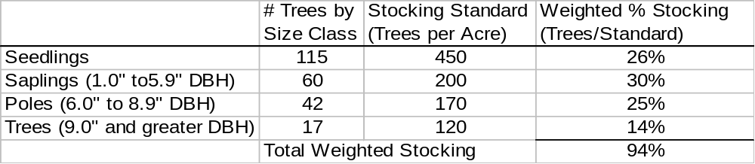

The weighted percent stocking for this reforestation unit would be 94 percent of the minimum standard. An additional 6% is needed to bring the unit up to the minimum standard. An additional 27 tree seedlings per acre (6% X 450 trees/acre) that have survived on site for two years would bring the unit up to the minimum standard.

VI. Survey Exemptions on Private lands

Stands that are significantly composed of insect and disease-killed, fire-killed, wind-thrown, or fatally damaged trees may be exempted from reforestation. “Significantly composed of” is considered to be greater than 70 percent of the basal area or commercial trees in the stand. To apply for an exemption from reforestation requirements under this section, a landowner must request an exemption in the reforestation section of a detailed plan of operations under 11 AAC 95.220(10) or a change in operations under 11 AAC 95.230 and must demonstrate that the affected stand is significantly composed of insect- and disease-killed, fire-killed, wind-thrown, or fatally damaged trees.

If required by the division, the request must include a description of the sampling procedure, the sampling data, and a data summary. The data summary must show the number of commercial trees per acre that are dead or fatally damaged, and the percentage of commercial trees in the stand that are dead or fatally damaged. Sample plots must be located without bias throughout the affected stand. For stands of 1,000 acres or less, the minimum sample density is 10 plots per 100 acres. For stands greater than 1,000 acres, the minimum sample density is six plots per 100 acres. Fewer plots are acceptable if the sample standard error is less than 10 percent of the mean. Either fixed diameter or variable plot sampling methods are acceptable. Sample plots must average approximately five sample trees of commercial size. Trees must be recorded by diameter class as either dead, damaged by insects, disease, fire, wind, or not impacted. The division may accept other documentation or field evidence in lieu of sampling in cases where the extent of damage is obvious.

VII. Reforestation Timing

Regions. Alaska’s Forest Resources and Practices Act divides the state into three forest practices regions. Reforestation must be achieved within the time frame indicated for the region.
- Region I – Coastal Forest – 5 years after harvest.
- Region II & III – Interior Forest – 7 years after harvest.

Responsibility. Schedules for stocking surveys and analysis of results on state land are the responsibility of area foresters.

Results. Each stocking survey should result in (1) an indication of stocking levels, (2) recommended treatment, and (3) resurvey recommendations.

VIII. Designing stocking surveys

A. Survey methods. The two survey methods that are generally acceptable are circular plot and nearest tree. These methods are described below.

1. Circular plot method. The circular plot method uses a fixed area plot (Table 3), which is constant by Alaska Forest Resources and Practices region. This system compares the number of stocked plots to unstocked plots to determine stocking, and uses averages to determine trees per acre.

Table 3. Plot size by forest region
Plot Size Plot Radius
Region I - Coastal Forest 1/200 acre 8.33 feet
Region II&III - Interior Forest 1/450 acre 5.55 feet

2. Nearest seedling method. The nearest seedling method measures the distance from the plot center to the nearest established seedling or advance regeneration. Stocking information is made from a ratio using the median value of distance to tree. Distribution is estimated from the percentage of area that has the minimum number of required trees per acre.
Breaking points for nearest seedling by forest region:
Region I (Coastal): 11.7 ft. max distance = 200 effective trees / acre.
Region II&III (Interior): 7.8 ft. max distance = 450 effective trees / acre.
These breaking points are the maximum distance to determine if the site meets the minimum stocking requirements. For sites which may or may not meet the minimum it is suggested that the survey extend out several feet further then this minimum breaking distance. A survey in Region I should survey out to 15 feet and a survey in Region II & III should extend to 10 or 11 feet for the breaking distance. Then if a survey shows that the minimum stocking is not met, the actual stocking can be calculated. This information will show how deficient the stand is. For instance, a landowner in Region II may find out his stand does not contain 450 trees per acre but can calculate that it contains 250 trees/acre. This will allow the landowner to make a better decision as to how to bring the site up to the required stocking level.

B. Choosing the Best Survey Method. The nearest seedling method is preferred because this method is less biased than the circular plot system. Stocking estimates can be overestimated using the circular plot method if there are areas of dense stocking within areas having poor stocking. However, in areas of poor stocking in dense brush or grass, the circular plot system may be more reliable and efficient.

C. Required number of plots.

1. State land. For state land, reforestation surveys will, at a minimum, sample units at 1.09 plots per acre (0.92 acres/plot), which is a 200 foot by 200 foot grid. Table 4 lists the number of sampling plots required based on the acreage of the regeneration survey.

Table 4. Number of sampling plots required

Acres # of plots
0-4 min. of 5 plots/acre
5-10 54
11-30 64
31-74 84
75+ 1.09 plots/acre

2. Private land. For private land, reforestation surveys will, at a minimum, sample units based on the following:
  - For areas 200 acres and less, surveys will sample units at 1.09 plots per acre (0.92 acres/plot), which is a 200 foot by 200 foot grid
  - For areas greater than 200 acres, surveys will sample units at 0.48 plots per acre (2.07 acres/plot), which is a 300 foot by 300 foot grid.

IX. Detailed description of field data collection methods and computing the results

A. Circular plot method. Each plot is a fixed area of 1/200 or 1/450 acre, depending on the forest practices region, all acceptable regeneration is recorded up to a maximum of 10 seedlings by species. Larger sized plots can be used where stocking is limited or especially spotty. For example a 1/50th acre plot can be used in Region III and record all species in the plot. Each tree within the plot then corresponds to 50 trees per acre so that for a plot to be considered stocked must contain 9 trees (9 X 50 = 450) per acre. This has the advantage of being able to determine some gradation of how deficient a non-stocked plot is. A plot that has 7 trees versus a plot that only has none or 1 tree are both non-stocked but will take less planted trees to bring them up to the standard.

1. On a site map of the largest scale available, draw grid lines. Points of intersection are plot centers. Run grid lines perpendicular and parallel to predominant topography. Assign reference azimuth to grid.

2. Visit plot location as drawn on map and record regeneration and ground data (see Reforestation Survey Tally Form, p. 12). Record no more than 10 seedlings for any species for each plot.

3. Instructions for completing the reforestation survey tally form.

Item Title Description of area and survey design (circular plot method)
(1) Line: Enter the survey line numbers in alphanumeric order.
(2) Plot: Enter the plot numbers in alphanumeric order.
(3) Species: Enter the species code. Use abbreviations of common names, e.g.,

WH Western Hemlock TR Tamarack
SS Sitka Spruce WS White Spruce
BR Birch BS Black Spruce
CW Cottonwood RC Red Cedar
YC Alaska Yellow Cedar BP Balsam Poplar
LP Lodgepole Pine LS Lutz Spruce

(4) History: 0 Residual tree
1 Sucker
2 Natural seedling/sapling
3 Planted seedling/sapling
(5) # Trees: Enter the number of trees, per age class, per species. Any species having more than 10 stems within a plot is recorded as 10+.
(6) Height: Enter the height to the nearest foot per species.
(7) Age: Enter the age class per species. Age classes should not be averaged if the difference equals or exceeds five years.
Methods of determining age:
  - Count the number of whorls on most coniferous reproduction.
  - Estimate age based on local experience for hardwoods and for those conifers which do not have apparent whorls.
  - Increment bore and count the rings if the stem is large enough.
  - Estimate the age of hardwood stands if no ring count can be made.
  - Check sale reports on logged areas.
  - Check fire reports on burned areas.
(8) DBH: Enter the DBH to the nearest inch of each residual.
(9) Form: For each residual: Y=good phenotype N=poor phenotype
(10) Type: Refer to Tatum Aid
(11) Degree: Refer to Tatum Aid
(12) Agent: Refer to Tatum Aid
(13) Type: Enter the predominant site type code for each plot. On measured plots, record up to three site type codes based on declining percent crown cover. Refer to Tatum Aid.
(14) Height: Enter the height to the nearest foot for each of the recorded site types.
(15) Percent: Enter the estimated crown coverage of each recorded site type, by area, of the plot in percent.
(16) Drainage: 0 Very poor
1 Poor
2 Moderately well
3 Well
4 Excessive

4. Computing results
- Total the number of acceptably stocked plots with subtotals for each major species.
- Percent stocking
  - To estimate percent stocking for all observations, divide the number of stocked plots by the total number of stockable plots; multiply by 100.
  - To estimate percent stocking by species, divide the total number of plots of observed species by the total number of stockable plots and multiply by 100.

percent stocking by species = Observed sample by species x 100
Total possible stockable sample

- To estimate trees per acre find the mean ( x ) number trees per plot Multiply the mean by 200 for Region I or 450 for Region II or III or if you use a different plot radius, multiply by the appropriate factor.

In the example plot in Table 5 there are:
- 22 total plots
- 2 non-stockable plots
- 15 total stocked plots
- 12 plots stocked with spruce
- 6 plots stocked with hemlock
- 4 plots stocked with cottonwood
- 14 plots stocked with spruce or hemlock
The total number of trees in the stocked plots is 26 spruce, 12 hemlock, and 19 cottonwood.

The total percent stocking in the example is then 15 stocked plots/20 stockable plots X 100 or 75% stocking.

Total spruce and hemlock stocking in the example is 14 stocked plots/20 stockable plots X 100 or 70% stocking.

Percent non-stockable = 2/22 = 9%

The number of trees per acre in this example from Region I is 57 trees / 20 stockable plots = 2.85 trees per plot X 200 = 570 trees per acre.

The number of spruce and hemlock trees per acre is 38 spruce & hemlock / 20 stockable plots -= 1.9 trees per plot X 200 = 380 trees per acre.
Reforestation Survey Tally Form: Circular Plot Method

REFORESTATION SURVEY TALLY FORM |  |  |  |  |  |  |  |  |  |  |  |  |  |  |  | Page _______ of ________
Sale ID: |  |  |  |  | Unit # |  |  |  |  |  |  |  |  |  |  | Elevation:
 |  |  |  |  |  |  |  |  |  |  |  |  |  |  |  | Area:
Legal Description: |  |  |  |  |  |  |  |  |  |  |  |  |  |  |  | Plot Size:
 |  |  |  |  |  |  |  |  |  |  |  |  |  |  |  | Survey Line Azimuth:
Date: |  |  |  |  | Surveyed By: |  |  |  |  |  |  |  |  |  |  | Number of Plots:
 |  |  |  |  |  |  |  |  |  |  |  |  |  |  |  | Aspect:
Sample |  | Reproduction Stand |  |  |  |  | Residuals |  | Damage |  |  | Site |  |  |  | Remarks
Line | Plot | Species | History | No. Trees | Height | Age | DBH | Form | Type | Degree | Agent | Type | Height | Percent | Drainage
Tatum Aid

Type of Damage: Causative Agent:

NA - no damage 10 - leaf chewers
ST - stem 11 - leaf miners
BR - branch 12 - leaf rollers
TW - twig 13 - sapsuckers (aphids)
LD- leader 14 - other insect damage
RT - root 15 - shoot dieback
NF - new foliage 16 - other disease damage
OF - old foliage 17 - nutrient deficiency
BD - bud 18 - fire
DC - discoloration 19 - moose/deer/elk
VG - vegetative competition 20 - rabbit/hare
LS - layered seedling 21 - mice
MD - mechanical damage 22 - porcupine
23 - beaver
Degree of Damage: 24 - livestock: cattle/horses
25 – livestock: sheep/goats/pigs
0 - no apparent damage 26 - other animal damage
1 - foliage damage 0-25% 27 - snow
2 - foliage damage 26-50% 28 - wind
3 - foliage damage 51-100% 29 - frost
4 - tree dying 30 - frost heaving
5 - tree dead 31 - drought
32 - flood
site type 33 - forbs and grass
34 - shrubs
10 - nonstockable 35 - logging damage
11 - grass 36 - slash suppression
12 - fireweed 37 - herbicide
13 - devil's club 38 - if “other” and known,
14 - willow identify in “remarks”
15 - blueberry
16 - ferns
17 - horsetail
18 - geranium
19 - alder
20 - dwarf birch
21 - labrador tea
22 - rusty menziesia
23 - salmonberry
24 - spirea
25 - moss
26 - slash and debris
27 - highbush cranberry
29 - rose

Table 5. Example of Circular Plot Tally

REFORESTATION SURVEY TALLY FORM |  |  |  |  |  |  |  |  |  |  |  |  |  |  |  | Page _______ of ________
Sale ID: |  |  |  |  | Unit # |  |  |  |  |  |  |  |  |  |  | Elevation:
 |  |  |  |  |  |  |  |  |  |  |  |  |  |  |  | Area:
Legal Description: |  |  |  |  |  |  |  |  |  |  |  |  |  |  |  | Plot Size:
 |  |  |  |  |  |  |  |  |  |  |  |  |  |  |  | Survey Line Azimuth:
Date: |  |  |  |  | Surveyed By: |  |  |  |  |  |  |  |  |  |  | Number of Plots:
 |  |  |  |  |  |  |  |  |  |  |  |  |  |  |  | Aspect:
Sample |  | Reproduction Stand |  |  |  |  | Residuals |  | Damage |  |  | Site |  |  |  | Remarks
Line | Plot | Species | History | No. Trees | Height | Age | DBH | Form | Type | Degree | Agent | Type | Height | Percent | Drainage
1 | A | SS | 3 | 1 | 1.2 | 3 |  |  |  |  |  | 12 | 3 | 80 | 3
 |  |  |  |  |  |  |  |  |  |  |  | 26 | 1 | 20
1 | B | SS | 3 | 3 | .9 | 2 |  |  |  |  |  | 16 | 2 | 20 | 3
 |  | WH | 2 | 1 | 3.5 | 7 |  |  |  |  |  | 22 | 3 | 40
1 | C |  |  |  |  |  |  |  |  |  |  | 10 |  | 100 |  | Nonstockable due to slash
1 | D | SS | 2 | 4 | 1.8 | 4 |  |  |  |  |  | 12 | 3 | 30 | 3
 |  | WH | 2 | 4 | 2.9 | 6 |  |  | LD | 1 |  | 16 | 3 | 40 | 2 | Dead leader
1 | E |  |  | 0 |  |  |  |  |  |  |  | 22 | 2 | 70 | 2
1 | F | SS | 3 | 4 | 1.9 | 5 |  |  |  |  |  | 12 | 3 | 60 | 3
 |  | CW | 2 | 5 | 6.8 | 6 | .9 | Y |  |  |  | 26 | 1 | 25 | 3
 |  | WH | 2 | 1 | 3.9 | 5
2 | A | WH | 2 | 4 | 1.6 | 5 |  |  |  |  |  | 12 | 3 | 70 | 2
2 | B | SS | 3 | 3 | 1.9 | 4 |  |  |  |  |  | 12 | 3 | 60 | 3
2 | C | SS | 2 | 1 | 2.2 | 6 |  |  |  |  |  | 12 | 3 | 50 | 3
 |  | CW | 2 | 2 | 3.9 | 4 |  |  |  |  |  | 22 | 3 | 40
2 | D |  |  | 0 |  |  |  |  |  |  |  | 13 | 3 | 80 | 1
2 | E |  |  | 0 |  |  |  |  |  |  |  | 16 | 3 | 60 | 2
 |  |  |  |  |  |  |  |  |  |  |  | 26 | 1 | 70 | 1
2 | F | SS | 3 | 1 | 2.2 | 4 |  |  |  |  |  | 26 | 2 | 40 | 3
2 | G |  |  | 0 |  |  |  |  |  |  |  | 12 | 3 | 50 | 2
3 | C | SS | 3 | 1 | 2.5 | 6 |  |  |  |  |  | 26 | 3 | 50 | 3
3 | D | SS | 3 | 3 | 2.6 | 5 |  |  |  |  |  | 26 | 3 | 60 | 3
3 | E |  |  | 0 |  |  |  |  |  |  |  | 10 |  |  |  | Slash Pile non-stockable
3 | F | SS | 3 | 1 | 2.1 | 4 |  |  |  |  |  | 16 | 3 | 40 | 2
 |  |  |  |  |  |  |  |  |  |  |  | 26 | 1 | 30
3 | G | WH | 2 | 1 | 2.5 | 6 |  |  |  |  |  | 12 | 3 | 40 | 3
4 | E | CW | 2 | 10 | 5.8 | 5 | .7 | Y |  |  |  | 26 | 3 | 40 | 2
4 | F | SS | 3 | 3 | 2.4 | 6 |  |  |  |  |  | 12 | 3 | 70 | 2
 |  | WH | 2 | 1 | 3.2 | 5
 |  | CW | 2 | 2 | 3.4 | 5 |  |  |  |  |  | 12 | 3 | 60 | 3
4 | H |  |  | 0 |  |  |  |  |  |  |  | 12 | 3 | 70 | 4
4 | G | SS | 3 | 1 | 2.6 | 4 |  |  |  |  |  | 12 | 3 | 60 | 2

B. Nearest seedling method
1. Determine grid layout as for circular plot system and draw onto a site map.
2. Refer to the Reforestation Survey Nearest Seedling Tally form on page 18. At each plot, search for and measure the distance to the nearest established seedling or advanced growth. A stick marked at 1 foot intervals, a loggers tape, or a cord with knots or tape at one foot intervals will be helpful.

3. Determine whether the tree is over-topped or free-to-grow. Use the diagram in Figure 1 to help determine free-to-grow.

Figure 1. Determining overtopped vs. free-to-grow trees.

Project a cone upward from the tree

If 2/3 of the cone is blocked by shrubs, the tree is overtopped. Otherwise it is free-to-grow.
Note: If the nearest tree is overtopped, but there is a free-to-grow tree within several feet and within the breaking distance, ignore the overtopped tree and measure the distance to the nearest free-to-grow tree.

4. Tally the tree or seedling under the correct column in the correct distance class. Information concerning species, history, height, and age is the same as described in the instructions for the circular plot tally on pages 8-9. “N-stock” refers to non-stockable which is defined on page 3.
5. Carefully search each point. Failing to find and measure the nearest tree will introduce serious error. Most field time and work will be spent on traveling to the points. Therefore, take all the time needed on the points themselves.
6. Use the Reforestation Survey Nearest Seedling Tally Form on page 18 to record data for the nearest seedling method. Record distance only at 1-foot intervals. Example: A ‘closest seedling’ measured to be 4.3 feet should be tallied as ‘within 5 feet’.
7. If there is no tree within the breaking distance for the survey (either 11.7 ft. in the coastal region or 7.8 ft. in the interior region) leave the area next to plot blank. Double-check the point before leaving plot!
8. Computing results. Refer to the example in Table 8.
- Subtotal the following columns: overtop, height, age, n-stock, and limiting distances columns.
- percent of Total: the cumulative total number of sampled seedlings divided by the total possible seedlings.
- Average Age - Subtotal of age column divided by the number of stocked count plots.
- Average Height - Subtotal of height column divided by number of stocked count plots.
- Percent Stocked but Overtopped - Subtotal of over top column divided by total number of stocked plots.
- Percent Free to Grow - percent satisfactory stock not free to grow minus 100.
- Percent Non-stockable - Total N-stock column divided by total of all plots.
- Calculate the median number of seedlings in feet (see example in Table 6). Convert this to seedlings per acre by using Table 7, and enter the trees per acre value on the form. Note that the median is calculated from the distances less than the limiting distance! (7.8 ft. or 11.7 ft.) Also, this is the number of seedlings per acre of the stocked portion of the survey. To get the total stocking, add those observations greater than the breaking point.

The median is defined as the central number of a series; that is where half the numbers are greater than the median and half are less.

Usually this will only isolate the median to a range, e.g., 5’ to 6’. Calculate a decimal equivalent by noting the position of the median in the range and the number of samples in the range and fractioning.

Table 6. Example calculation of median number of seedlings

Range | Points | Median is the (24 + 1)/2 = 12 1/2 number: this is the average of the 12th and 13th number and is in the 5’ to 6’ range and is the average of the first and second number of the five numbers. As a fraction this is 5 and 3/10 or 5.3. (There are 5 trees in the 5’ to 6’ range so as a percentage each tree equals .2 feet or 5.2, 5.4, 5.6, 5.8 & 6.0 so the fraction comes from 5.2 + 5.4 for the first and second trees divided by 2 or 5.3 feet).
0’-2’ | 3
2’-3’ | 4
3’-4’ | 2
4’-5’ | 2
5’-6’ | 5
6’-7’ | 1
7’-8’ | 2
8’-9’ | 0
9’-10’ | 1
10’-11’ | 3
11’-12’ | 1
subtotal | 24

Table 7. Conversion of median to effective trees per acre

Median | Trees/Acre | Median | Trees/Acre | Median | Trees/Acre
12.2 | 50 | 5.4 | 250 | 3.8 | 500
9.9 | 75 | 5.2 | 275 | 3.5 | 600
8.6 | 100 | 5.0 | 300 | 3.3 | 700
7.7 | 125 | 4.8 | 325 | 3.0 | 800
7.0 | 150 | 4.6 | 350 | 2.9 | 900
6.5 | 175 | 4.4 | 375 | 2.7 | 1,000
6.1 | 200 | 4.3 | 400 | 2.2 | 1,500
5.7 | 225 | 4.1 | 450

9. Making a quantitative estimate of animal damage and/or competing vegetation. The nearest trees are a quasi-random sample. If each is recorded as “damaged” or “not damaged” or as “in the presence of competing vegetation” or “not in the presence of competing vegetation,” percents can be calculated.
Table 8. Example of Nearest Seedling Tally

REFORESTATION SURVEY NEAREST SEEDLING TALLY FORM |  |  |  |  |  |  |  |  |  |  |  |  |  |  |  |  |  |  |  | Page _______ of ________
Sale ID: |  |  |  |  | Unit #: |  |  |  |  |  |  |  |  |  |  |  |  |  |  | Elevation:
 |  |  |  |  |  |  |  |  |  |  |  |  |  |  |  |  |  |  |  | Area:
Legal Description: |  |  |  |  |  |  |  |  |  |  |  |  |  |  |  |  |  |  |  | Plot Size:
 |  |  |  |  |  |  |  |  |  |  |  |  |  |  |  |  |  |  |  | Survey Line Azimuth:
Date: |  |  |  |  | Surveyed By: |  |  |  |  |  |  |  |  |  |  |  |  |  |  | Number of Plots:
 |  |  |  |  |  |  |  |  |  |  |  |  |  |  |  |  |  |  |  | Aspect:
Sample |  | Reproduction Stand |  |  |  |  | Limiting Distance |  |  |  |  |  |  |  |  |  |  |  |  | Remarks
Line | Plot | Species | History | Overtop | Height | Age | N-Stock | 1 Foot | 2 Foot | 3 Foot | 4 Foot | 5 Foot | 6 Foot | 7 Foot | 7.8 Foot | 9 Foot | 10 Foot | 11 Foot | 12 Foot
1 | 1 | WS | 0 |  | 1’ | 4 |  |  |  |  | X
 | 2 | BR | 2 |  | 2’ | 3 |  |  |  |  |  | X
 | 3 |  |  |  |  |  | X |  |  |  |  |  |  |  |  |  |  |  |  | Old landing/Log Deck
 | 4 |  |  |  |  |  |  |  |  |  |  |  |  |  |  |  |  |  |  | Dense alder
 | 5 | BP | 1 |  | 3’ | 3 |  |  |  |  | X
 | 6 | WS | 0 | X | 1’ | 2 |  | X |  |  |  |  |  |  |  |  |  |  |  | Alder brush
 | 7 | BP | 0 |  | 2’ | 3 |  |  |  |  | X
 | 8 | BP | 2 |  | 3’ | 3 |  |  |  |  |  |  |  | X |  |  |  |  |  | Moose browsed
 | 9 | WS | 2 |  | 2’ | 5 |  |  | X
 | 10 | WS | 2 |  | 1’ | 2 |  |  |  | X
 | 11 | BR | 2 |  | 3’ | 5 |  |  |  |  |  | X
 | 12 | WS | 0 |  | 7’ | 12 |  |  |  |  |  | X
 | 13 | WS | 2 | X | 3’ | 5 |  |  |  |  |  |  |  |  | X |  |  |  |  | Alder next to tree
 | 14 | BP | 1 | X | 2’ | 3 |  |  |  | X |  |  |  |  |  |  |  |  |  | Alder
 | 15 | WS | 0 | X | 5’ | 8 |  | X |  |  |  |  |  |  |  |  |  |  |  | Alder by slough
 | 16
 | 17 | WS | 2 | X | 1’ | 2 |  |  |  |  | X
 | 18 |  |  |  |  |  |  |  |  |  |  |  |  |  |  |  |  |  |  | Alder
 | 19 | BP | 2 |  | 2’ | 4 |  | X
 | 20 | WS | 2 |  | 1’ | 3 |  |  |  |  |  | X
 | Subtotal
 | % of total |  |  | 5 | 39 | 67 |  | 3 | 1 | 2 | 4 | 3 | 1 | 1 | 1
 |  |  |  |  |  |  |  | 15% | 20% | 30% | 50% | 65% | 70% | 75% | 80%

Average Age = 67/16 = 4.2 Years  Average Height = 39/16 = 2.4 feet  Median Distance Stocked Area = (16+1)/2= ½ way between 8th and 9th number or between the second and third number of four numbers between3 and 4 feet or 3.6 feet = 570 trees /acre  Median Distance Total Area = (20+1)/2= ½ way between 10th and 11th number or between 4.0 feet and 4.33 feet or 4.2 feet = 425 trees/acre  Percent satisfactorily stocked & free to grow = 11/16 = 69%  Percent satisfactorily stocked but overtopped = 5/16 = 31%  Percent non-stocked but stockable = 3/20 = 15%  Percent non-stockable = 1/20 = 5%  Reforestation Survey Nearest Seedling Tally Form |  |  |  |  |  |  |  |  |  |  |  |  |  |  |  |  |  |  |  | Page _______ of ________
Sale ID: |  |  |  |  | Unit #: |  |  |  |  |  |  |  |  |  |  |  |  |  |  | Elevation:
 |  |  |  |  |  |  |  |  |  |  |  |  |  |  |  |  |  |  |  | Area:
Legal Description: |  |  |  |  |  |  |  |  |  |  |  |  |  |  |  |  |  |  |  | Plot Size:
 |  |  |  |  |  |  |  |  |  |  |  |  |  |  |  |  |  |  |  | Survey Line Azimuth:
Date: |  |  |  |  | Surveyed By: |  |  |  |  |  |  |  |  |  |  |  |  |  |  | Number of Plots:
 |  |  |  |  |  |  |  |  |  |  |  |  |  |  |  |  |  |  |  | Aspect:
Sample |  | Reproduction Stand |  |  |  |  | Limiting Distance |  |  |  |  |  |  |  |  |  |  |  |  | Remarks
Line | Plot | Species | History | Over Top | Height | Age | N-Stock | 1 Foot | 2 Foot | 3 Foot | 4 Foot | 5 Foot | 6 Foot | 7 Foot | 8 Foot | 9 Foot | 10 Foot | 11 Foot | 12 Foot

X. Mapping seedling distribution

A. Map symbols. Maps will be made for all units surveyed by a grid. Construct a regeneration map from available scale maps containing the following:

Map Symbols

Cutting boundary * * *
Survey lines ____________
Streams ____ . . . ___
Roads _ _ _ _ _ _ _ _
Plots - (Note: these are suggested symbols)
D Deleted Plot
Nonstocked
● Stocked conifer or hard wood
Stocked w/conifer
Stocked w/hardwood
a Stocked w/aspen or cottonwood
h Stocked w/hemlock
s Stocked w/spruce
b Stocked w/birch

B. Map Contents. The final regeneration map should contain the following information.
1. Cutting area boundary
2. Survey lines
3. North arrow
4. Total block acreage
5. Location of survey lines
6. Location of plots
7. Scale
8. Roads
9. Streams
10. Contours
11. Original type
12. Sections of 10 acres or more of poorly stocked areas.

C. Identifying unstocked areas within a generally stocked unit.
Starting at one corner of the unit, proceed line-wise and examine 5 plots at a time. After the first 5 plots are examined, drop the first plot in the line and take the next 5 plots (running average of 5 plots) and keep moving to the end of the line until the last 5 plots are checked.
A row of 5 plots is called stocked if there are 3 or more plots stocked out of 5. A row of plots is called unstocked if it has 3 or more unstocked plots. Five is a convenient number for such a “ Moving average’ because 3 stocked plots out of 5 plots coincides with 60 percent stocking. If there are fewer than 5 plots in a line, all plots must be stocked in order to call the whole line stocked.
If there are more than 5 plots in a line, the beginning of the first unstocked 5 plots should be marked, and the end of the last unstocked 5 plots should be marked to cut out the unstocked portion of a line.
After each line is checked and marked, the marked areas should be joined to show the boundaries of the suspected unstocked areas. Only tally those areas that have greater than 10 non-stocked acres. The same procedure is to be repeated by running the 5 plot moving average down the rows, vertically. The area indicated to be non-stocked in both directions shall be considered part of the area requiring treatment.
Forest Practices Regulation 11 AAC 95.375 (d)(4) states that no more than 10 percent of the harvest area or contiguous areas may be below the stocking levels. Areas identified through this method that exceed 10 percent of the harvest area must receive some type of treatment to bring the stocking levels up to the required standards. For an example of this technique, see Appendix III.

XI. Final Report

The final report for all surveys is a completed copy of the Regeneration Report (page 21) and a final regeneration map, developed according to specifications in this manual. Whenever practical, include ground level photographs to document site conditions. Copies of the final Regeneration Report should be sent to the Regional Forester.
Notes on filling in the Regeneration Report. Treatment recommended is based on the survey. In many cases the survey will only identify and quantify the problem, and further investigation will be needed to determine the treatment recommended. In these cases, indicate the need for such a check. Resurvey depends on the degree of seedling establishment. If it should be resurveyed in 1, 2, or 3 years, state that. If it is the final survey, state that.

Regeneration Report

Sale or Rehabilitation Area _______________________________________________________________
_____________________________________________________________________________________
Portion, if stratified __________________________________________________________________

Acreage __________ Location __________________ SEC _____ TWP _____ RNG _____ MER _____

Survey Date __________________ Surveyed by: _____________________________________________

Harvest Date _________________

Summary

____________________ acres satisfactorily stocked

____________________ acres satisfactorily stocked that need release (overtopped or not free-to-grow)

____________________ acres understocked but stockable

____________________ acres not stocked or stockable

The stocked area averages __________________________ trees per acre.

Average age is ____________________ Average height is ____________________

Treatment recommended: _______________________________________________________________________________________________________________________________________________________________________________________________________________________________________________________________________________________________________________________________________________________________________________________________________________________________________

Resurvey Recommended _______________________________________________________________________________________________________________________________________________________________________________________________________________________________________________________________

Comments (animal, damage, competing vegetation, etc. ): _________________________________________________________________________________________________________________________________________________________________________________________________________________________________________________________________________________________________________________________________________________________________________________________________________________________________________

XII. Regeneration survival checks

Plantings should be checked for the estimation of survival percentage to provide a basis for the success or failure of a particular planting project.

Two methods of survival checks are proposed.

- One method is to stake 100 or more individual planted trees and to return to those trees the following season to see how many of them survived and what condition they are in. These can be tracked for one season or over several years to determine the success of a planting project.

- A second method is to run a transect across the planted unit marking plot centers every 200 feet. At each plot center planted trees are noted as to distance and bearing from the plot center out to a distance of 16.65 feet (1/50 acre). The trees are again visited in the following season to determine survival percentages. This method has the advantage of determining the number of seedlings being planted per acre. Naturals may also be recorded to give an estimate of total stocking.

The sample plots are to be established at the time of planting or immediately afterwards. Both the plots and the seedlings should be clearly marked so that they are recognizable at the time of assessment, which is normally three growing seasons after planting. If the plots are not established at the time of planting, the invading vegetation may make it impossible to locate the planted trees and planting rows.

Appendix I – Theory: Nearest Seedling Method

Note: The following theory is provided for background information. It’s not necessary to understand the theory to carry out the procedure.

Dr. Scott Overton of Oregon State University has developed a mathematical theory of stocking and tree distribution. This theory lends itself to random point to nearest-tree-distance sampling. Dr. Overton has shown that this type of sampling is considerably less biased than methods relying on quadrats, plots, or transects.

The theory requires the choice of an assumed tree distribution pattern - random, rectangular, square or triangular. Either square or rectangular is suitable for plantations, and can also be used on natural stands. Research with British Columbia Douglas-fir has shown that plantation distributions of up to 2:1 rectangles will fully utilize the site. Therefore, we have chosen a 2:1 rectangular distribution for application on state forest lands. Such a choice gives a plantation the benefit of the doubt, but does not count all of the crowded trees in a natural stand.

The theory measures ‘effective trees’ only. By counting only effective trees the theory produces a minimum estimate. This is sufficient for deciding whether a stand is satisfactorily stocked but does not allow an estimate of total overstocking.

Basic mathematical theory

If trees are in a rectangular distribution with a distance of 2x between rows and 4x between columns.
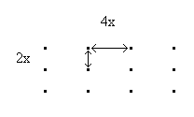
we can show: (a) that each tree occupies an area of 8x²

(b) that the maximum distance from any point to the nearest tree is 5x

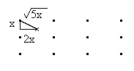
and (c) that the median distance from a series of points is 1.16564 x. (this latter distance is calculated by calculus and statistics and is intuitively acceptable).

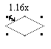

We can add units to these relationships by noting that the area occupied by each tree is:

43560 square feet per acre
n trees per acre

Setting this equal to 8x² and solving for x we have

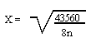
and using x we have the median distance as:

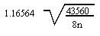
and the maximum distance as

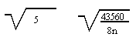
These distances are given for various trees per acre values. For 200 trees per acre this equates to 11.7 and for 450 trees per acre it is 7.8.

Nonstocked Theory

If we define a given number of well distributed trees as a standard (e.g. 200 trees per acre) and further define this to mean on a 2:1 distribution or better, we can compute the percent of the area that is nonstocked. Note that any random point that falls further than the maximum distance
(11.7 feet for 200 trees per acre) is an opening of 23 feet or more in
diameter.

The portion of such an opening that is farther than 11½ feet from the nearest tree is nonstocked by our standard. The percent of all points beyond the maximum distance represents the percent of the area that is nonstocked. This percentage can be directly converted to acreage.

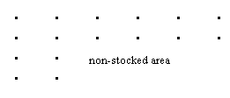

Effective Tree Theory

A fully effective tree is one which is at the center of a rectangle formed by four nearest trees. Effective trees are fully counted by nearest tree sampling.

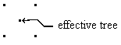

A completely non-effective tree is one which is immediately adjacent to another effective tree. Such trees are not counted by nearest tree sampling since they do not affect median distance.
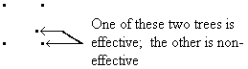

A partially effective tree is one located between the two extremes noted above. Such partially effective trees affect the median in proportion to the square of their relative distance from an effective tree. As such they are partially counted.
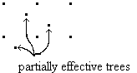

The estimate of effective trees given by nearest tree sampling is the sum of effective trees (each counts one) and partially effective trees (each counts as a faction from 0.01 to 0.99 depending on location).

Effective tree theory means that crowded trees are counted only if they are on a regular pattern.

e.g. desires:
. . .
(effective trees = total trees)


crowded in a regular pattern
(effective trees = total trees)

crowded off a regular pattern
(effective trees< total trees)

This means that effective tree per acre estimate will be either equal to or lower than the total trees per acre. A high estimate will signal a need for pre-commercial thinning, but a low estimate does not necessarily mean that pre-commercial thinning is not needed.

Conversely, crowded trees out of pattern will not substitute for unstocked openings to yield an erroneous average.

Statistical Error and Sample Size

Dr. Overton has indicated that the estimate of the percentage of non-stocked and stocked is more sensitive to sample size than the estimate of effective trees per acres. The standard deviation of this estimate is:

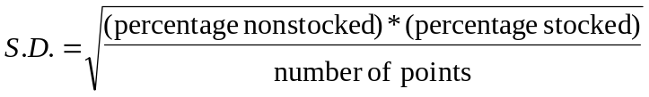

The standard deviation is maximized when percent nonstocked is 50 percent. The standard deviation is zero when percent nonstocked is zero or 100 percent.

A sample of 50 points will give a standard deviation of 5 percent in 15 percent nonstocked stands and 7 percent in 50 percent nonstocked stands.

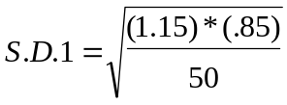

S.D. 1 = 5%

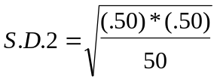

S.D. 2 = 7%

The 95% confidence level calls for a range of plus and minus two standard deviations.

This means that a sample of 50 points will give an estimate that is within + 14% at the worst case and within + 10% at the more normal 15% nonstocked level. Therefore, this sample size is adopted in the procedure described here. (Note that the above percents are percent nonstocked, not a percent of the estimate.)

Appendix II - Waiver of sampling procedures

If the area to be surveyed is obviously stocked, then the form shown below should be filled out and submitted your supervisor for approval.

Waiver of sampling procedure request form

Report on stocking

Waiver of sampling procedure request

I, hereby state that the area logged

under Timber Sale No. is obviously stocked.

I have examined the area after completion of all timber operations on the total area logged under this plan. I believe that all areas operated on as indicated on the attached map are adequately stocked to meet the requirements of the Alaska Forest Resources and Practices Act and regulations.
APPROVAL

_________________________________________ _________________________________________
NAME SUPERVISOR NAME

_________________________________________
OFFICE DATE

DATE

Appendix III – Delineation of non-stocked (NSR) areas

Exhibit 1. Example of delineating NSR areas

Step 1 - West to East delineation of suspected unstocked area. Remember, there has to be 3 unstocked plots per 5 plots for the area to be outlined.

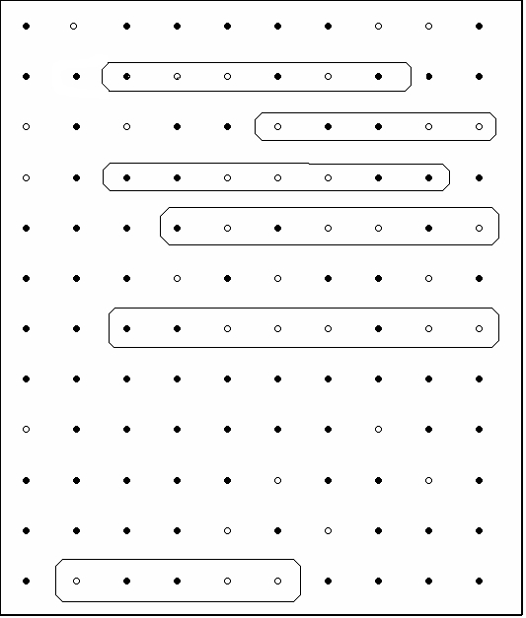
Line #

1

2

3

4

5

6

7

8

9

10

11

12

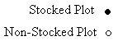

Exhibit 2. Example of delineating NSR areas

Step 2- North to South delineation of suspected NSR areas

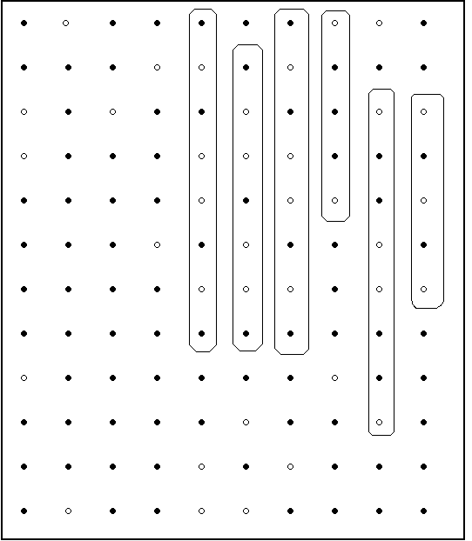 Line #

1

2

3

4

5

6

7

8

9

10

11

12

Exhibit 3. Example of delineating NSR areas

Step 3 – combine areas in Step 1 and Step 2 where they overlap in the NSR area. Line #

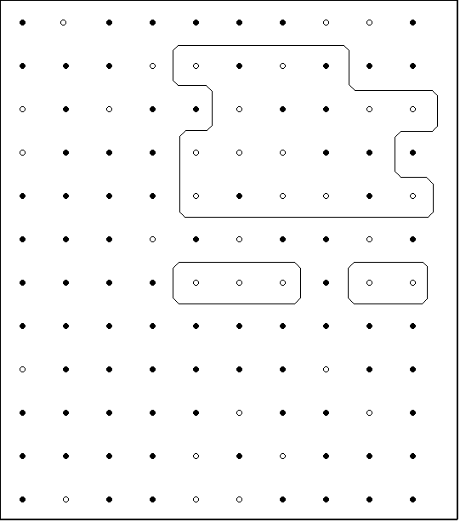

1

2

3

4

5

6

7

8

9

10

11

12

