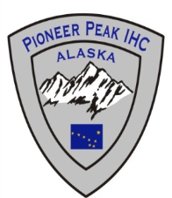
VACANCY ANNOUNCEMENT
Pioneer Peak Interagency Hotshot Crew

Wildland Fire & Resource Technician III Hotshot/Handcrew

Mat-Su Area Forestry, Palmer Alaska
Apply for all PPK positions at http://workplace.alaska.gov
- Search by Title for “Wildland Fire & Resource Technician”

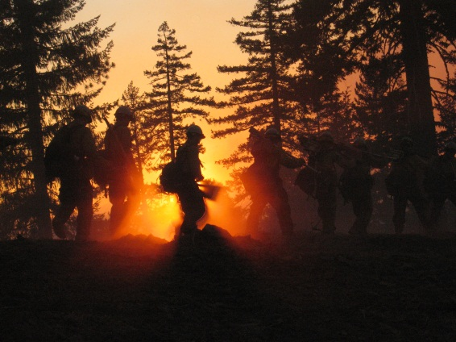
Specific to the Pioneer Peak Tech III Position Job Opportunity
The Wildland Fire & Resource Technician III position serves as one of three Permanent Crew Overhead on Pioneer Peak IHC. The duty station is Palmer, Alaska. The seasonal tour is March 1 –September 30.

Hotshot crews are the most highly trained firefighting crews that are also national, interagency resources. The Pioneer Peak Hotshot Crew Tech III’s purpose is to assist in leading and managing a squad (6-10) of highly effective, well-trained crewmembers in fire suppression and wildland urban interface/intermix incidents. The Tech III position is appropriate for those who meet Senior Firefighters/Squad Boss qualifications on Interagency Hotshot Crews as identified in the National Interagency Hotshot Guide.

The Pioneer Peak Hotsots are organized with a superintendent, an assistant, a foreman, two squad bosses and four senior firefighters. Typically the crew starts April 15 and works through the end of September, with the potential for a longer season based on project work and Lower-48 fire activity.

The incumbent must meet the qualifications specified in the IHCG Guide in order to qualify for and receive an interview request. Individuals must also posess a certificate of completion for S-290 intermediate wildland fire behavior and must include an IQCS master record with the application to document qualifications and training.
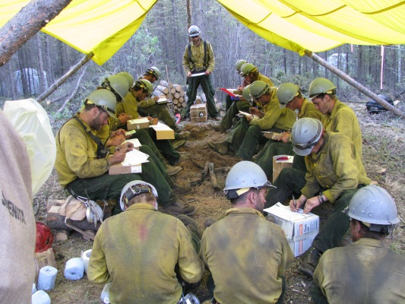
Process to Apply: *Note: This posting is valid through February 15, 2013 – Interested individuals will need to apply via Workplace Alaska - specific to this position and duty location - by the time and date specified. This position will be advertised on workplace alaska under the Palmer location as a “Wildland Fire and Resource Technician III.” The number for this job annoucement is PCN 10-DNR, open nationally for US Citizens. All applicants who have applied to the announcement on or before the listed date and are found to be qualified and in the quality group will be referred for consideration.
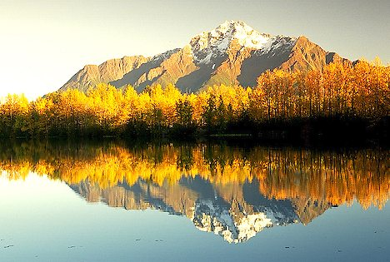
About the Mat-Su Area – Home of Pioneer Peak Hotshots!
The Alaska Division of Forestry, Mat-Su Area (MSS) provides fire protection and forest management for approximately 15.8 million acres in south-central Alaska. The Area’s northern boundary extends from Summit (south of Cantwell) east to Caribou Creek (mi. 106.8 Glenn Hwy). From Caribou Creek the boundary extends southwesterly to Portage. Moving westward from Portage, Mat-Su’s southern boundary follows the Turnagain Arm, across the Cook Inlet, to the northern Alaska Peninsula. The Area’s boundary then continues from the southernmost extent of the Lake Clark National Park & Preserve’s eastern boundary north to Rainy Pass, then following the Denali National Park & Preserve eastern boundary to Summit.

Within the Area there are approximately 375,000 residents in the fastest growing population center in the State. As a result, there is a high level of mutual aid and coordination with local cooperators, and a high level of public interaction. As part of DOF, operating under the Incident Command System (ICS), the area may respond to all risk incidents encompassing disasters such as search and rescue, flood, earthquake and oil spills.

The Mat-Su Area office is located in the city of Palmer within the Mat-Su Borough. The Borough is known for its scenic beauty, glacier-fed rivers and towering mountains. The terrain varies from sea level along Cook Inlet to portions of the Alaska Range with the tallest mountain in North America, Mount McKinley, just outside its northern borders. White and black spruce stands, birch, and mixed hardwood stands dominate the forested areas. Much of the landscape is the result of the Chugach, Alaska, and Talkeetna mountain ranges glacial activity. Summers are pleasant with warm days. Winds off the local glaciers can make firefighting a challenge.

The Area’s forest management, logistics support and fire dispatch all operate from the DOF facility located at the north end of the Palmer Airport, approximately 35 air miles, or 43 road miles, northeast of Anchorage. The Mat-Su Area management, administrative, and dispatch offices are located in the Administrative building of the DOF Palmer Facility complex. Also within the complex are the Coastal Region management offices, Central Office Procurement personnel, the DOF State Fire Warehouse Palmer Supply Facility (PSF), the Area’s initial attack helibase, and the Division’s Palmer Air Tanker Base. Mat-Su Dispatch, Prevention, Training, and Operations including all report to the Area Fire Management Officer (FMO). Area initial attack firefighters are stationed in the east end of the Palmer Supply Facility, and are pre-positioned throughout the Mat-Su Valley as fire potential and activity warrants.

About the Communities
Palmer - From the majestic Pioneer and Twin Peaks in the Chugach Range to the Talkeetna Mountains in southcentral Alaska, Palmer is framed in breathtaking beauty. Located 42 miles northeast of Anchorage on the Glenn Highway in the Matanuska Valley, the city's unique history and heritage are unparalleled in the state. The pedestrian-friendly downtown is filled with shops and boutiques with books, arts and crafts, and offerings from local artists, businesses, services, and farmers. Just a short drive from Palmer is Hatchers Pass which provides nearly 10 months of backcountry skiing and snowboarding. Biking, hiking, fishing, and river floats are just a few of the summer activities that the area provides.
Girdwood - Girdwood is situated in southcentral Alaska, just a 45-minute drive from Anchorage. The town of Girdwood, which has a permanent population of about 2,000, lies in a small valley in the Chugach mountains near the end of Turnagain Arm, part of the Cook Inlet. Girdwood, originally named Glacier City, is surrounded by no less than seven permanent glaciers. There is an abundance of outdoor activities in summer and winter. And Girdwood's temperate weather allows for these activities year-round. Visitors and residents alike enjoy hiking, rafting, fishing, kayaking, surfing and rock climbing in the summer; and Mount Alyeska, which looms at the end of the Girdwood valley, offers skiing and snowboarding throughout the winter months. There is also an abundance of cross-country trails within the valley in Moose Meadows near Girdwood's Hotel Alyeska.
Anchorage - Anchorage is located in Southcentral Alaska. The Chugach Mountains are east of the city, and waters of Cook Inlet border the city on the northwest and southwest. Anchorage encompasses 1,961 square miles and is a modern city with all the amenities. Although Anchorage is the states largest city, you are never more then 20 minutes from “Alaska”. The Municipality of Anchorage boasts an award-winning trail system citywide. Enthusiasts of skiing, running , biking, walking, horseback riding, hiking, roller blading, dog mushing, snowshoeing and ski-joring enjoy over 500 miles of maintained trails.
If you are interested in these positions please go to Workplace Alaska for a complete job description. Feel free to call or email with questions:

Matt Jones Norm McDonald

Superintendant Fire Management Officer

101 Airport 101 Airport Road

Palmer, AK 99645 Palmer, AK 99645

907-863-2016 907-761-6302 Desk

Fax 907-761-6319 907-863-2007 Mobile

matthew.jones@alaska.gov norman.mcdonald@alaska.gov

