How to download & access the new Dispatch Launcher
- Click on the link provided https://ak-ifm.selkirksystems.com/static/IFM%20Launcher-1.0.21.msi
- The launcher should download in your browser. Depending on the browser, you may need to approve the file for download. You can click on the arrow and select ‘Open when done’ to automatically have the launcher pop up once it is downloaded or click on the file once it is finished downloading.
- Some users may get the below message. Simply click ‘more info’ and ‘Run Anyway’.
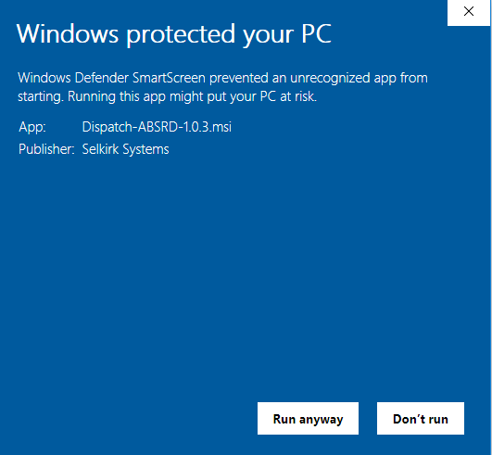
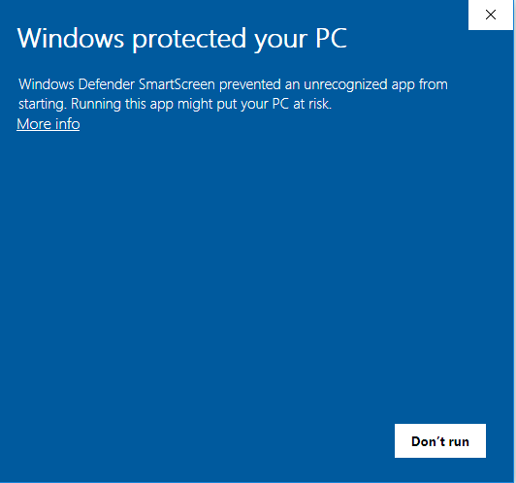
- If you get a message that looks like this: 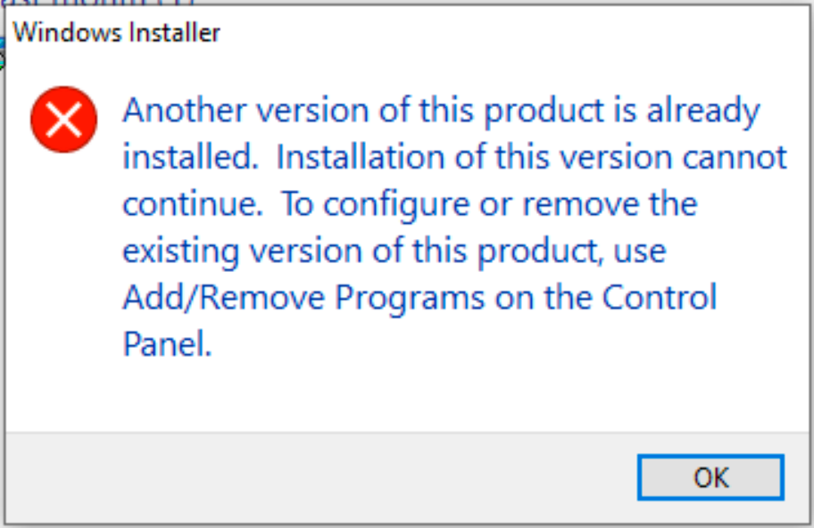
  - Go to Control Panel & Add/Remove programs
  - Select IFM Launcher and click Uninstall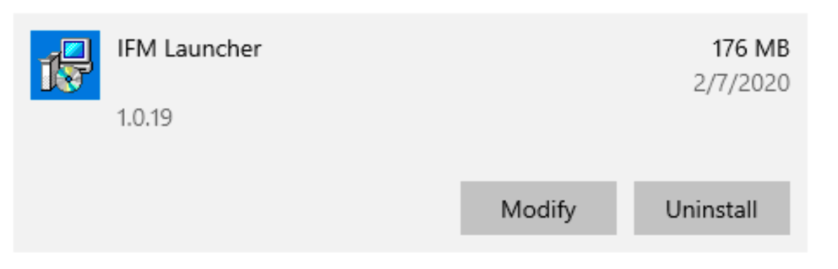
  - You may be asked to confirm several times, always choose the option that uninstalls or lets you change the local machine
  - Jump back to Step 2 and proceed

- It may take a few minutes for the next pop-up to appear. You will see the message below requesting changes to your computer.
- Selecting yes, the launcher should be fully downloaded.
- To access the launcher, go to your start menu
- You should see the launcher under ‘Selkirk’
- Click to open the launcher. Production will be the default application.
- To move the Dispatch icon onto your desktop for easy launching, drag the icon from the start menu onto your desktop or pin it to the taskbar by right-clicking the icon.
