Alaska Division of Forestry Interactive Scoping Map

This map is intended as a tool for the public to identify specific locations and add text describing why those locations are important to you.

Click “Basemap” to change the background map

Click “Map Layers” to turn data like roads or boundaries on/off

Click “Edit” to add a point marking a significant location

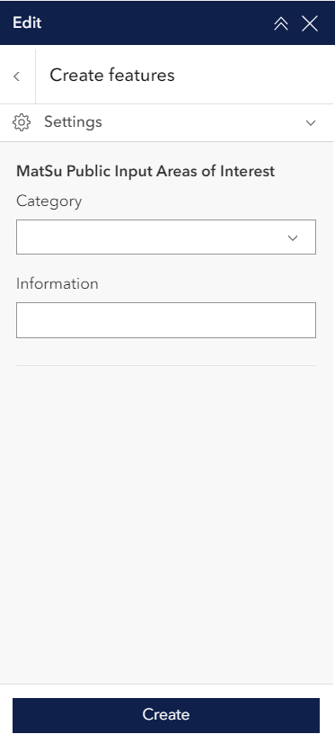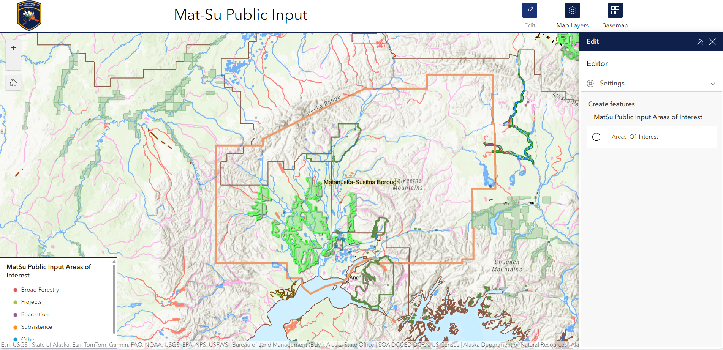

Categories related to forest classified lands.

Click here to add points to the map

Zoom in (+) or out (-) on the map

Choose a category if your area of interest relates to forest topics and type your description in the “information” box and click “Create” to finish.